# Modified laptop table

# A Report

Submitted in partial fulfilment of the requirements for I year I semester course of

**Product Design Studio**

**In**

**Bachelor of Technology**

Submitted by

**B. Shiva Krishna (2103A51390)**

**K. Sri Tej (2103A51410)**

**T. Padmamani (2103A51433)**

Under the Guidance of

**Mr. (Goutham Raj)**

**(Asst. Professor)**



**Center for Design**

**SR University**

**Warangal Urban-506371, Telangana, India.**

# 

# DECLARATION

## We hereby certify that the work being presented in the design report entitled “**Modified Laptop Table**” in partial fulfillment of the requirement for the course of Bachelor of Technology and submitted to the Center for Design at SR University Warangal-Telangana, is an authentic record of our own work carried out under the supervision of **Mr. Goutham Raj**, Assistant Professor, School of Engineering, SR University. The matter embodied in this report has not been submitted in part or full to any other University or Institute.

**B. Shiva Krishna (2103A51390)**

**K. Sri Tej (2103A51410)**

**T. Padmamani (2103A51390)**

The external viva-voce examination of the student was held on successfully _______________

Internal Examiner External Examiner

**ACKNOWLEDGEMENT**

We express our gratitude to our guide Goutham sir for helping us to finish our project.

We also convey our thanks to Haripriya madam for making us understanding about different concepts.

We also thank to each and every person who helped us for our project.

# Table of Contents

List of Figures

List of Tables

Abstract……………………………………………………………………………………1

Chapter 1- Design Research………………………………………………………………

* 1. – Design Space
  2. - Research Gap
  3. - Ethnography Study using A.E.I.O.U.

Chapter 2- Design Issues and Problem Identification…………………………………….

2.1 – Identifying the users needs

2.2 - Jobs to be done (JTBD)

2.3 – Problem Statement

2.4 – Need Statement

Chapter 3- Concept Generation and Selection…………………………………………....

3.1 – Concept Generation

3.1.1 – Concept generation using SCAMPER

3.1.2 - Concept Sketches

3.2 – Concept Selection

3.2.1 – Parameters used

3.2.2 – Concept selected using tool- Reasoning

Chapter 4- Prototyping…………………………………………………………………....

4.1 – Product Architecture

4.2 – CAD model

Chapter 5- User Testing…………………………………………………………………....

5.1 – Idea pitching – Story boarding using value proposition canvas

Chapter 6- Conclusion and Future Scope.………………………………………………....

**List of Figures**

|  |  |  |
| --- | --- | --- |
| **S.No** | **Name of the Figures** | **Page no** |
| 1 | Table sketch-1 | 25 |
| 2 | Table sketch-2 | 25 |
| 3 | Finalised sketch | 26 |
| 4 | CAD models | 28 |
| 5 | CAD models | 29 |
| 6 | CAD models | 30 |
| 7 | Story boarding | 31 |

**List of Tables**

|  |  |  |
| --- | --- | --- |
| **S.No** | **Name of the Table** | **Page no** |
| 1 | Define | 12 |
| 2 | Locate | 13 |
| 3 | Prepare | 13 |
| 4 | Confirm | 14 |
| 5 | Execute | 14 |
| 6 | Monitor | 15 |
| 7 | Modify | 15 |
| 8 | Conclusion | 16 |

**ABSTRACT**

The domain space we have selected is “**Study room in a house**”. Generally, house comprises many activities like eating, sleeping, studying, cooking etc.

Out of such many activities we have selected studying activity to help students while using study table for writing or reading. We have choosen the existing table and made major modifications so that it can be used for multiple purposes.

Our design product has many innovative features compared to the existing one’s. some of the features of our product are: it can be used for storing books and other gadgets. It also comes with laptop elevator so that the user can adust to his required eye level. Whenever not in use it can be simply folded and put at corner of room thus, occupying less space. Coming to the materials we have used user-friendly materials which are safe and compatible to use. The price of our product is also affordable compared to existing table. Thus, from our research we assure that our product can replace the existing one giving better experience while using it.

# Chapter-1

**Design Research**

* 1. **Design Space:**

Domain or Design space is the research area on which we work for certain period of time, identify major problems, and try to give effective solutions.

The design space we have selected for our research is study room in house where research work has been carried out by us and identification of pains were noted.

* 1. **Research Gap:** We had our research for 72 hours. We had observed different activities their pains and gains.

**1.3 Ethnographic study using A.E.I.O.U:**

**Activity**

Activities are goal-directed sets of actions. What are the pathways that people take toward the things they want to accomplish, including specific actions and processes? How long do they spend doing something? Who are they doing it with?

**Sketch Summary of Activities**

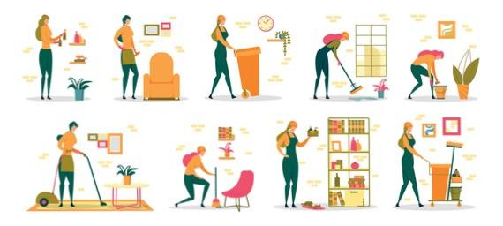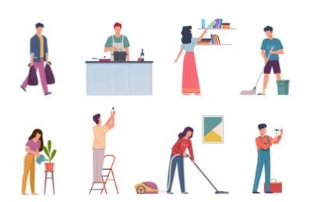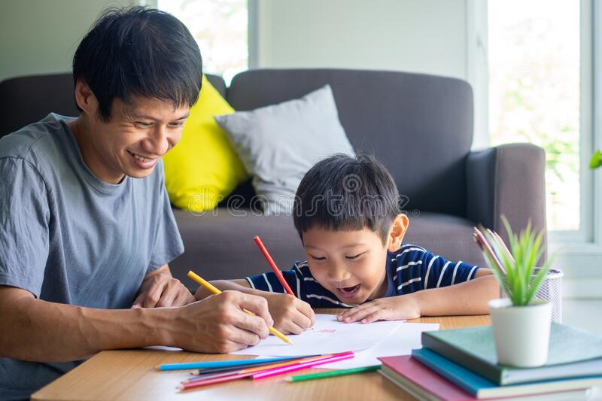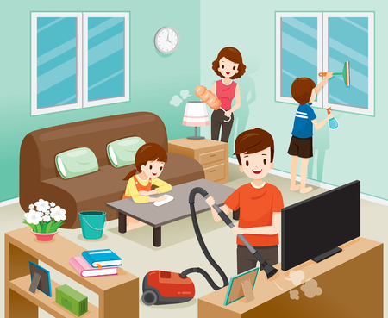

**Elements, Features & Special Notes**

* House compromises many activities such as cleaning, cooking, studying, taking rest. Thus, there are many products used for various factors.
* Every activity leads to benefit user to accomplish their goals.

**General Impressions/Observations**

1. Cleaning the house.
2. Washing Vegetables.
3. Cooking.
4. Bathing.
5. Washing clothes.
6. Studying.
7. Washing utensils.
8. Watching TV.
9. Brushing teeth

**Environment**

Environments include the entire arena where activities take place. For example, what describes the atmosphere and function of the context, including individual and shared spaces?

**Scenes**

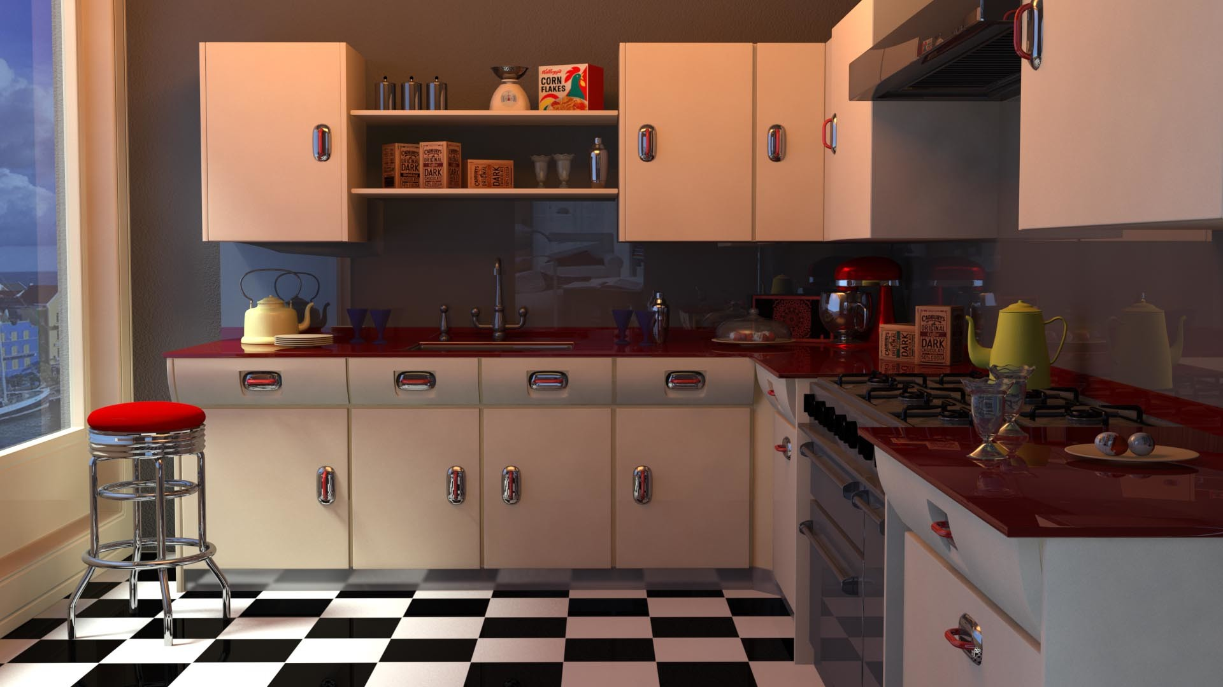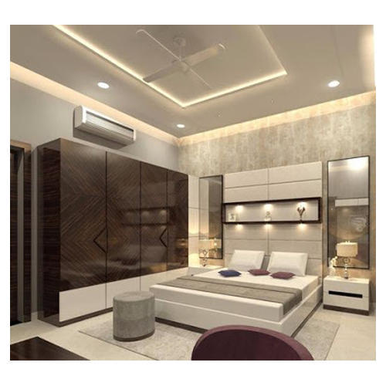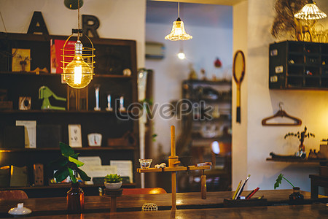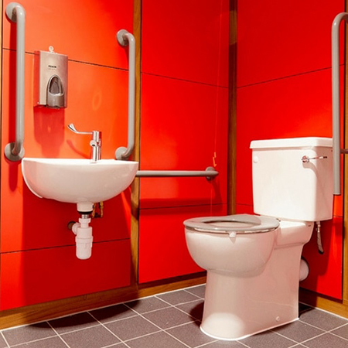

**Elements, Features & Special Notes**

* The environment is different. It is varying based on the requirement and usage of products.
* Environment tells the user where to work and how should he dressed.

**General Impressions of the Theme, Style, Materials & Atmosphere**

* The Environment in the house is healthy. People share their feelings, problems and have some solutions.
* KITCHEN:- The environment in kitchen is quite hot due to usage of Gas stoves and other appliances.
* HALL:- The environment in hall is enjoyable. Here, family members gather to watch TV, and have some entertainment.
* STUDY ROOM:- The environment here is quite serious. Students study and complete their works with keen concentration.
* BED ROOM:- Here , it is cool and lovely.

**Interaction**

Interactions are between a person and someone or something else, and are the building blocks of activities. What is the nature of routine and special interactions between people, between people and objects in their environment, and across distances?

**Scenes of Interaction**

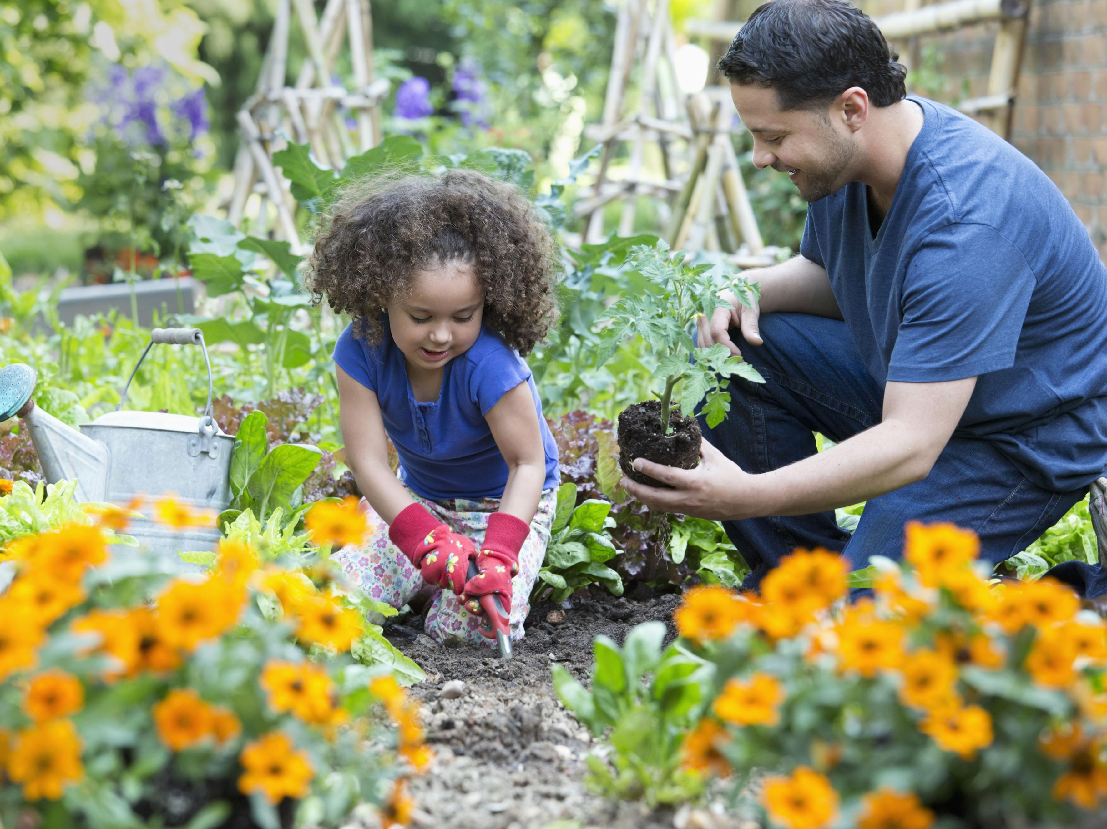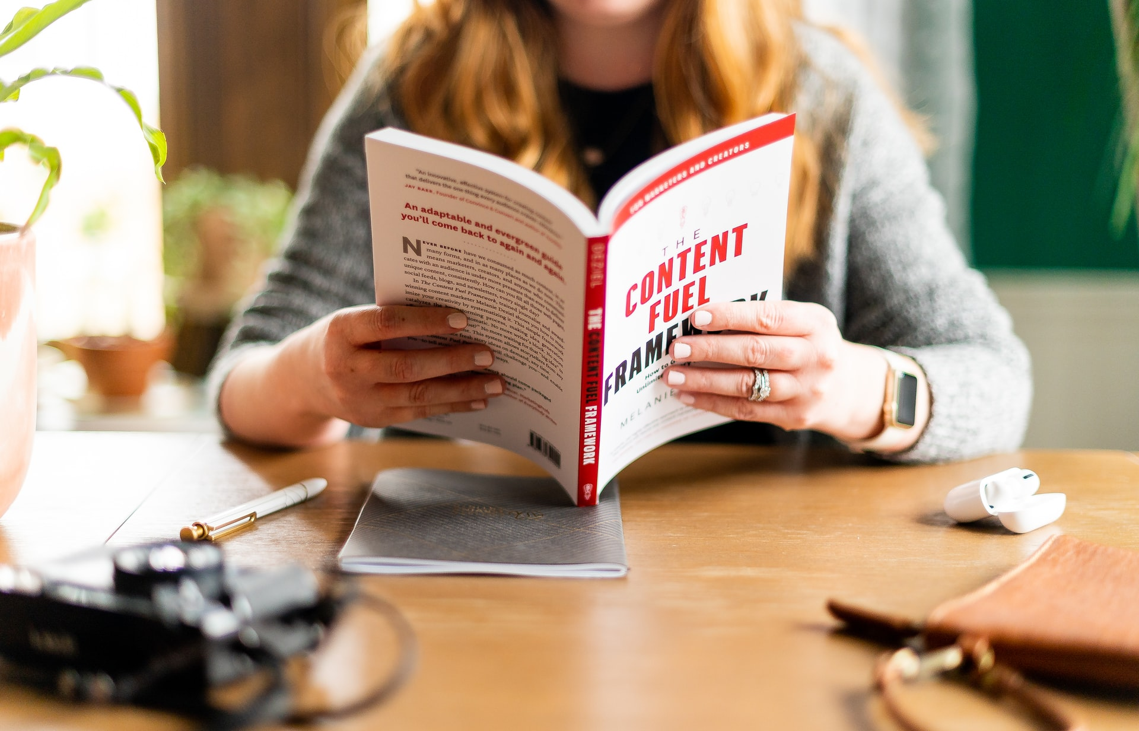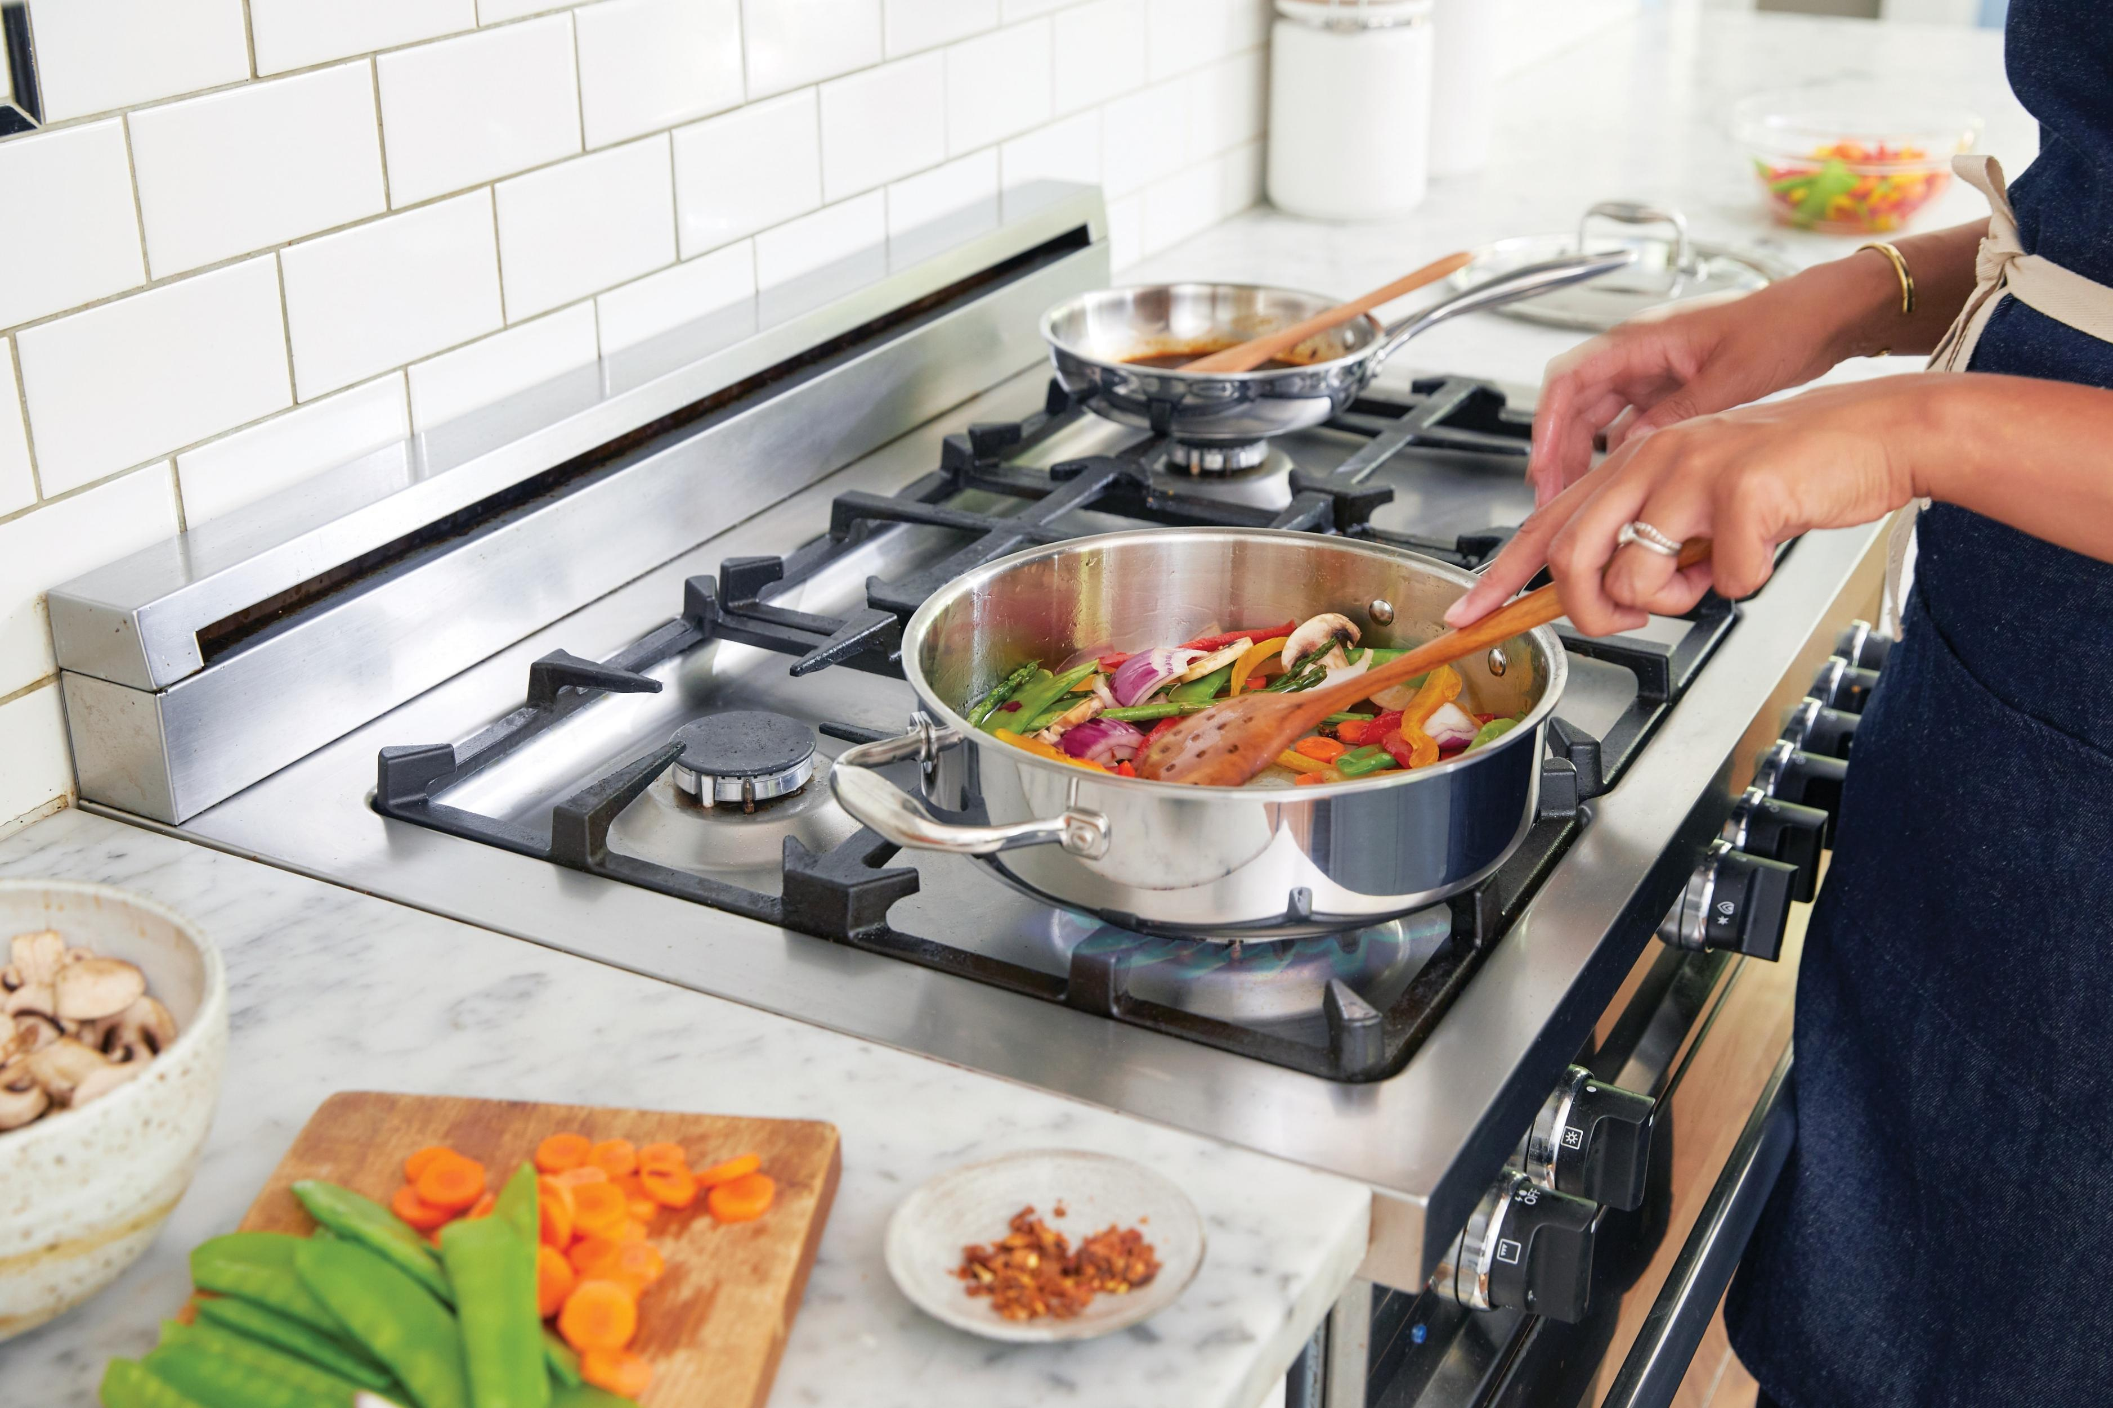

**Elements, Features & Special Notes**

* On interacting with members working for various purposes. I found that they have some problems with that products used for that purpose.
* They also gave some measures and suggestions so that pains in that products gets minimized.

**General Impressions/Observations**

* Up on interacting with members working in kitchen I found some products that are especially used for cooking. They also told that they have some problems using in some particular Products.
* Up on interacting with members in studying room I found products like books, tables etc they mentioned use of that products and some problems with them.
* Up on interacting with members in hall I found products like TV, sofa, cupboards, Toys etc. There are many products in the hall that can be modified and re-used.

**Object**

Objects are the building blocks of the environment, key elements sometimes put to complex or even unintended uses, possibly changing their function, meaning and context.

**Sketch Summary of Activities**

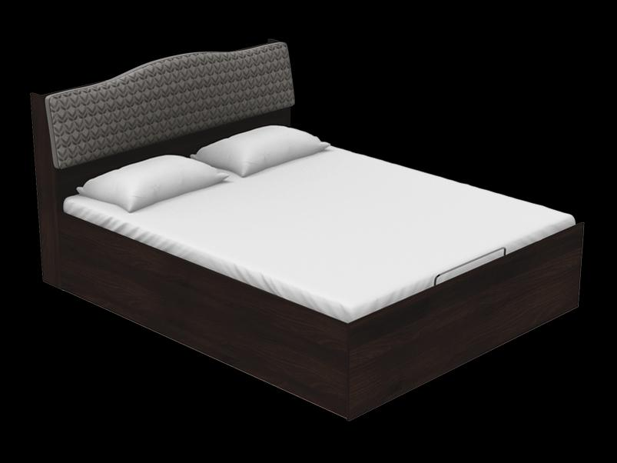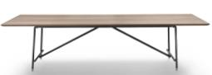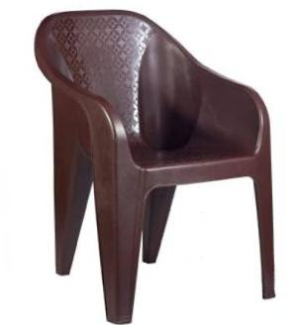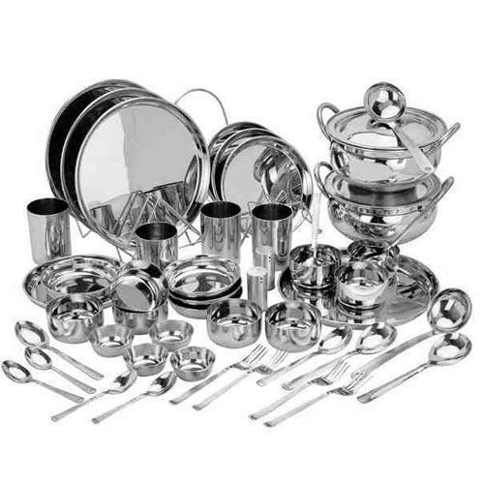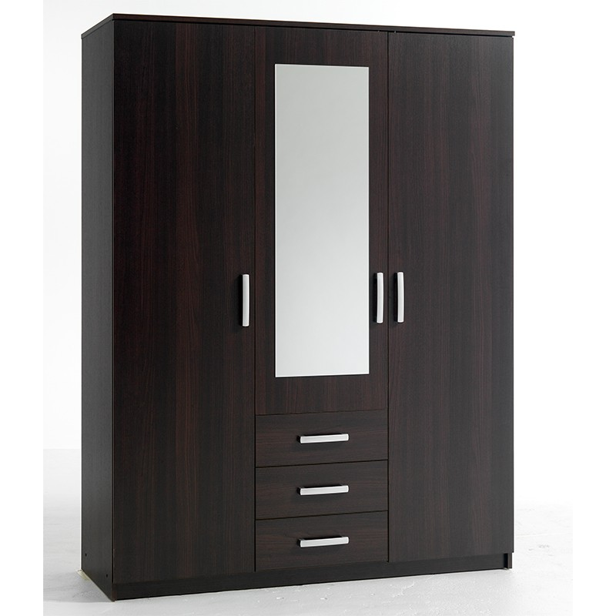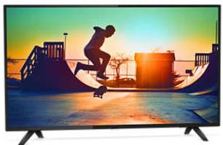

**General Impressions of the Theme, Style, Materials & Atmosphere**

|  |  |
| --- | --- |
| * **Tables** | * **Washing bins** |
| * **Chairs** | * **Sinks** |
| * **Bed** | * **Toys** |
| * **TV** | * **Books** |
| * **Mobiles** | * **Electrical appliances** |

**Elements, Features & Special Notes**

* Objects play important role in every use.
* Every product has some special use and they contribute to satisfy our needs.
* Sometimes some objects are difficult to use and cause some damage to our body.

**User**

Users are the people whose behaviors, preferences, and needs are being observed. Who is present? What are their roles and relationships? What are their values and prejudices?

**Sketch Scenes of Users in Context**

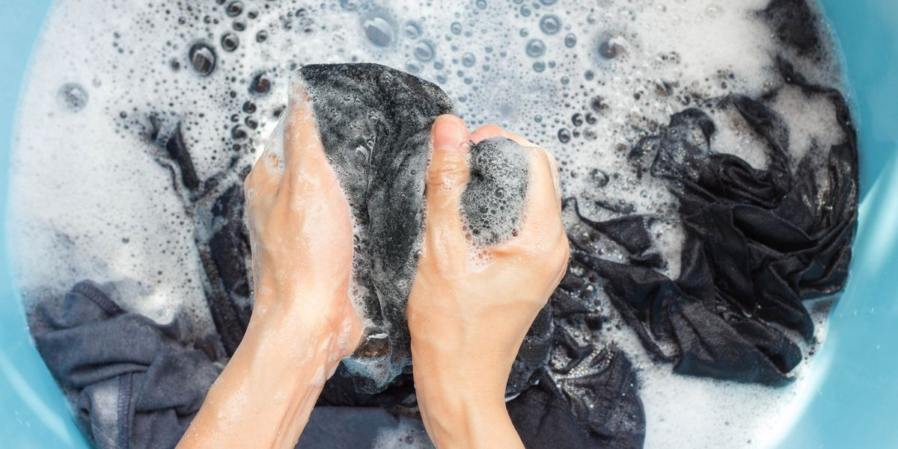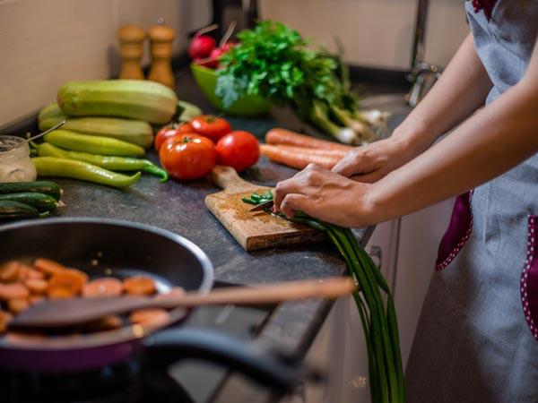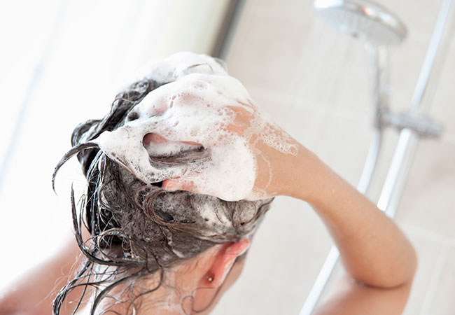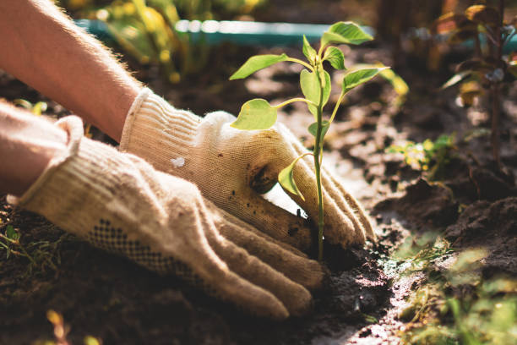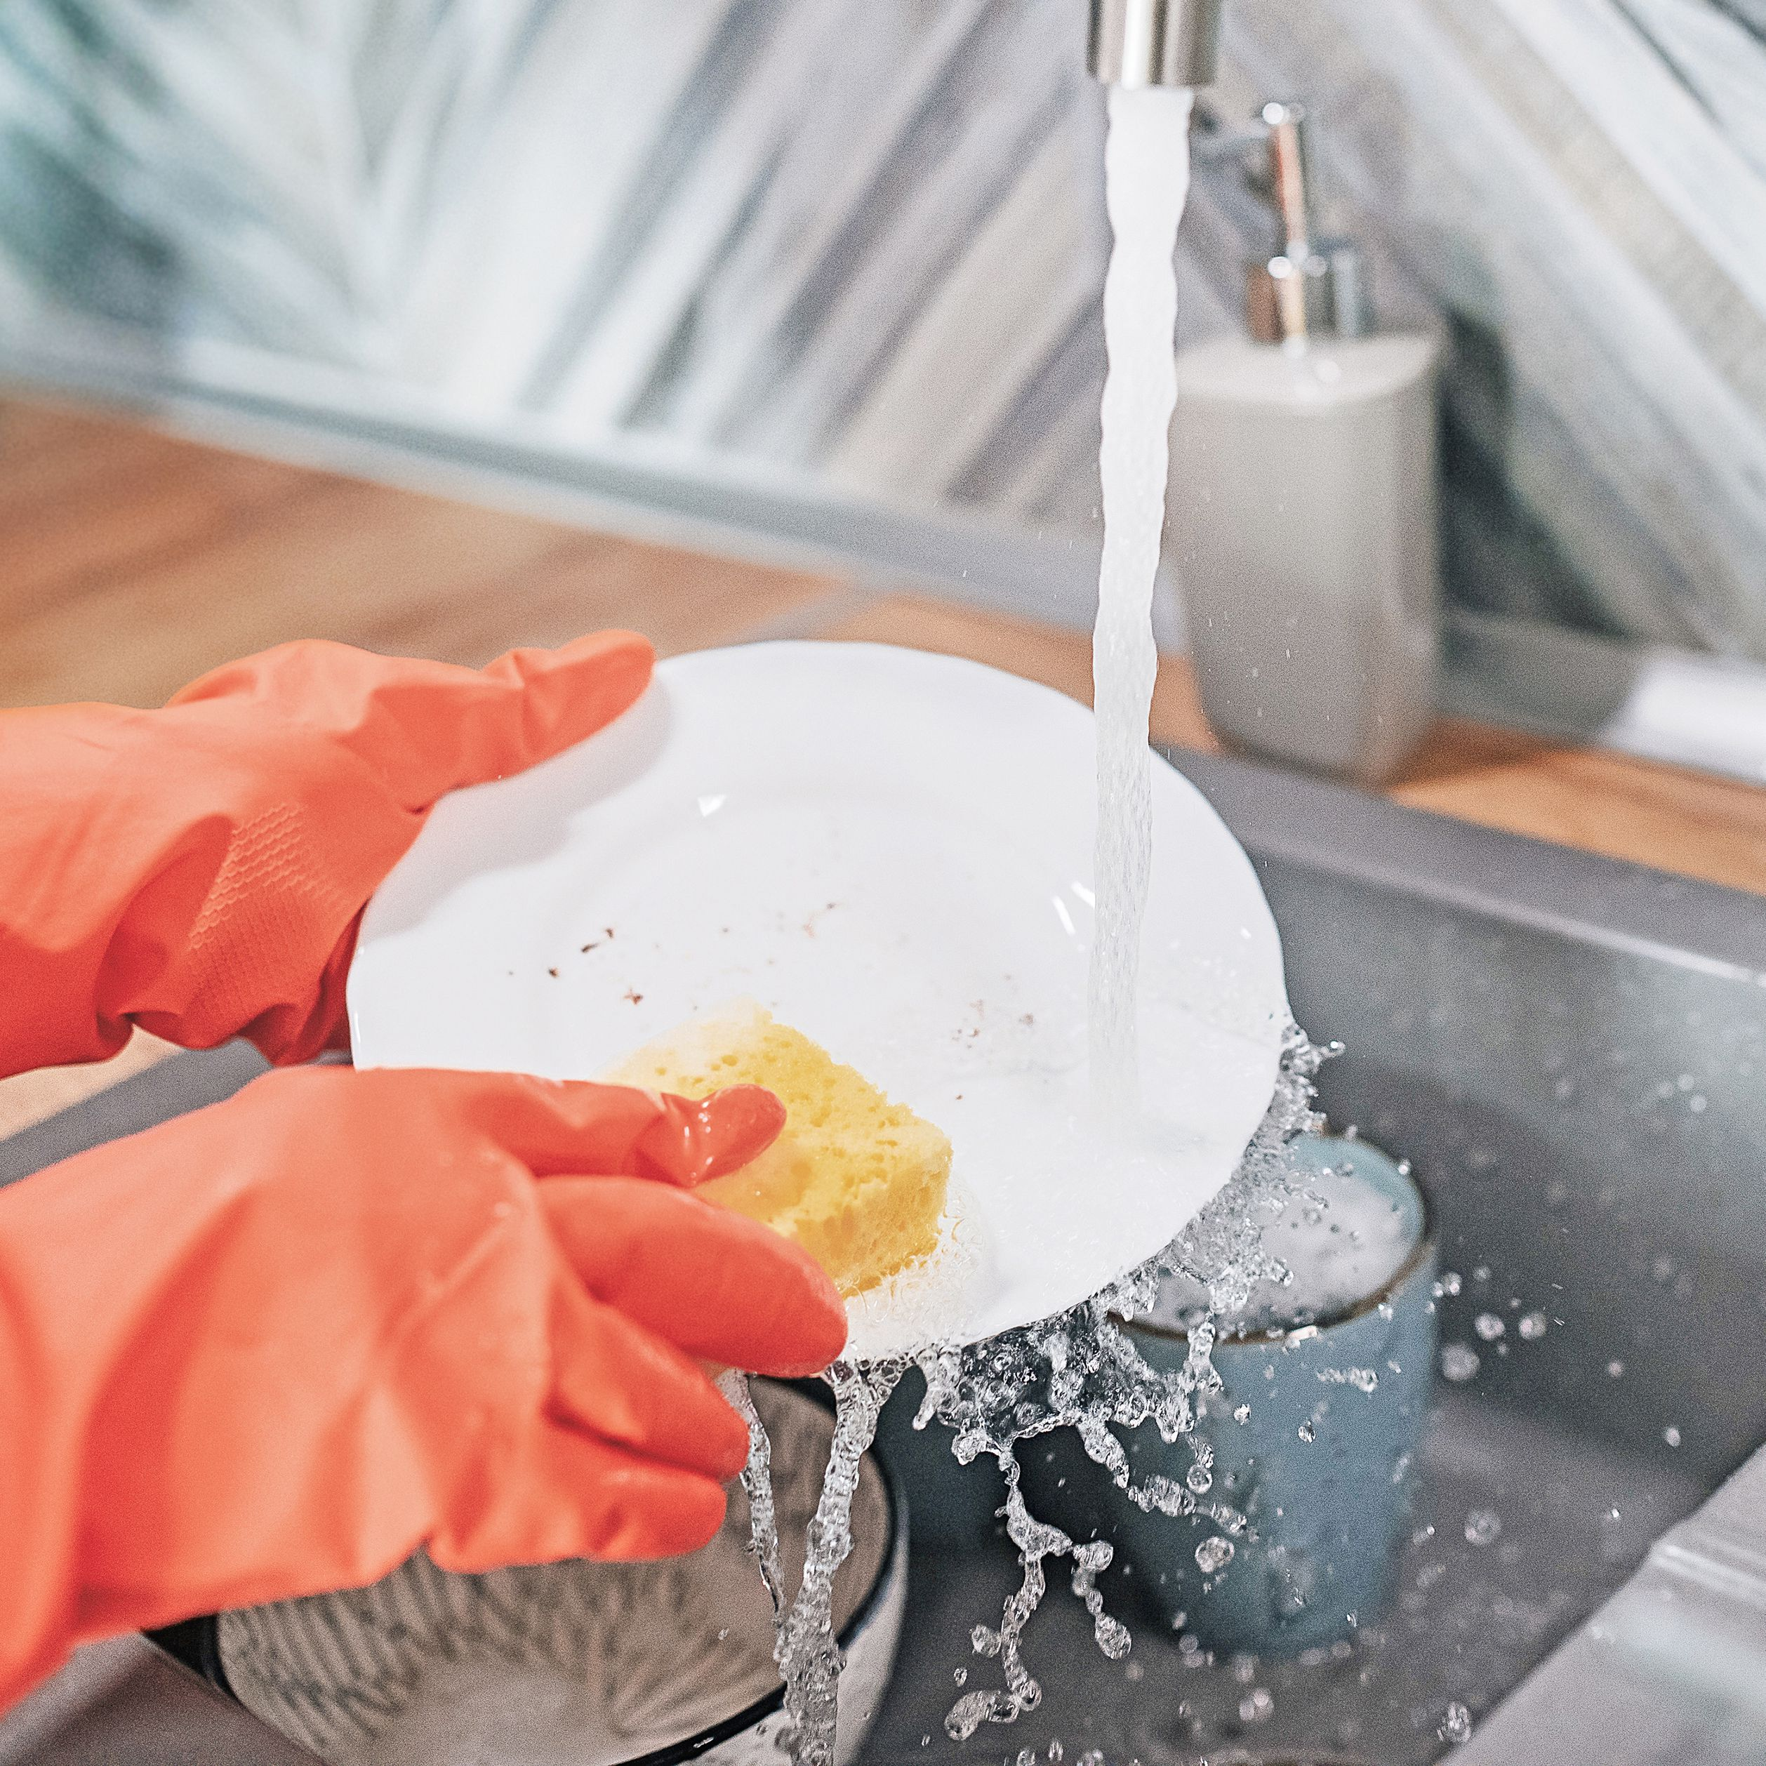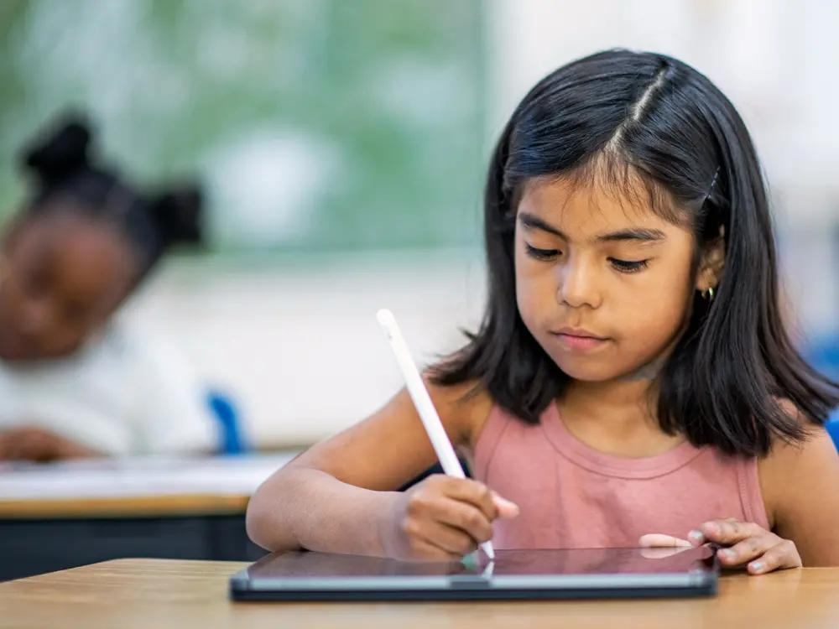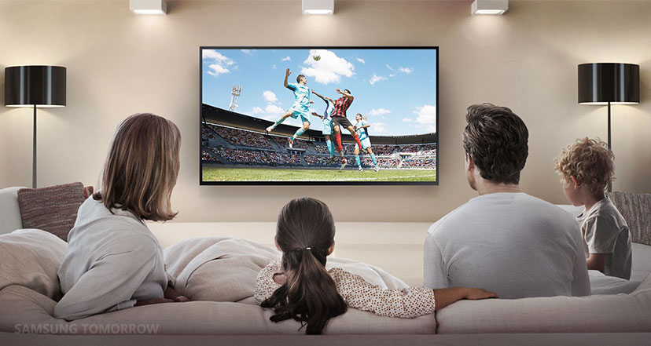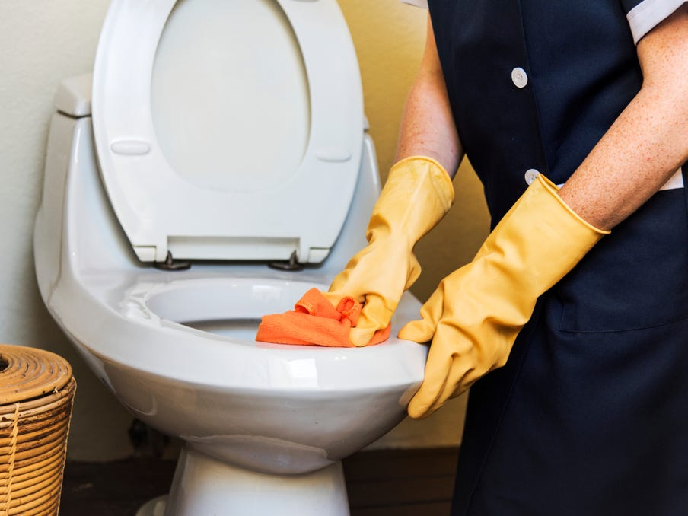

**Elements, Features & Special Notes**

* Based on the requirement the products used are different. To satisfy the needs of members in the family many products are required in their day to day life.
* User make use of products and finish their tasks.

**General Impressions of People in This Context**

* Tables, books are used by students to study
* Utensils, items required for cooking like knives, vegetables are being used by mother, sister and house worker.
* All members in the family use products in hall like cupboards, sofas, TV, mobiles to have some relaxation.

**Chapter 2**

**Design Issues and Problem Identification**

**2.1 Jobs To Be Done(JTBD):**

|  |  |  |
| --- | --- | --- |
| **Step** | **Activity** | **Pain points/ Pleasure points** |
| Define | * To reduce the strain faced by people while using laptop table. * Generally, users face many problems like back- pains while using laptop tables. * This happens due to lack of some features. Our idea is to provide some extra features to laptop table so that it can be used as effectively. | 1. Our product has some extra features which helps users to use comfortably. |
| Locate | * Our Modified Laptop table can be used in various fields like:- * At homes. * At Office. * While working with laptop. * While Studying. * While eating. * Thus, it is used where ever it is required. | * 1. Thus, it can be used for various purposes to satisfy the needs of users.   2. It can be used for multiple- purposes. |

|  |  |  |
| --- | --- | --- |
| **Step** | **Activity** | **Pain points/ Pleasure points** |
| Prepare | * It is made of user eco-friendly materials like wood, plastic and iron. * It is easy to prepare and use. | 1. The materials used are easily and readily available so that we can afford to buy it.    1. As there are some extra features include in our design the cost of table will be slightly more compared to the existing one’s. |
| Confirm | * We confirm to prepare our theme as :- * It is affordable to buy. * It can be used for various purposes. * It can absorb heat. * It is light- weight, easy to carry. * It can be folded after use. * We can adjust table based on our height and use. | 1. There are more gains than pains thus it becomes an effective design than the existing tables. |

|  |  |  |
| --- | --- | --- |
| **Step** | **Activity** | **Pain points/ Pleasure points** |
| Execute | * Our product is compactable to use at any conditions. * It occupies less space and can be placed at any corner of house after use. | 1. It also has stand which can be used to elevate laptop 💻 to our required angle. |
| Monitor | * It can be useful for any age group people like Children’s, Student’s, Employees, old age people etc. | 1. It can be easily cleaned and can withstand for longer duration. |

|  |  |  |
| --- | --- | --- |
| **Step** | **Activity** | **Pain points/ Pleasure points** |
| Modify | * Generally, the existing laptop tables are not compatible to use they causes many problems. We have identified major problems faced by user and adopted some techniques to minimize the difficulties. * Even in future our design is compactable to make/ add other changes. | 1. Thus, the modification of this table is simple and yields effective results. |
| Conclude | We, here by conclude that our design idea can become good alternative for existing products. | Thus, we conclude that our product can replace existing product by adding effective and innovative features. |

**2.2 Problem Statement:**

Users while using laptop tables facing back pains and many problems they need a way to fix these problems so that they can be benefited while using laptop tables.

**2.3 Need Statement:**

Users are facing difficulties while using laptop tables. By modifying the existing tables and adding extra features helps user’s to finish their tasks comfortably**.**

**Chapter 3**

**3.1 Concept Generation**

**3.1.1 Concept generation using SCAMPER**

**CONCEPT DEVELOPTION USING SCAMPER:-**

**S- Substitute**

**C- Combine**

**A - Adopt**

**M- Magnify/Minimize**

**P- Put to other use**

**E- Eliminate**

**R- Reverse/Rearrange**

Since most of people are facing problems during Studying or working while using laptop tables we try to develop new ideas to design new laptop table so that it is easy and comfortable to use for them.

**1.SUBSTITUTE:-**

* We substitute bulky materials like wood with iron and fibre so that it can be easily available and affordable.
* 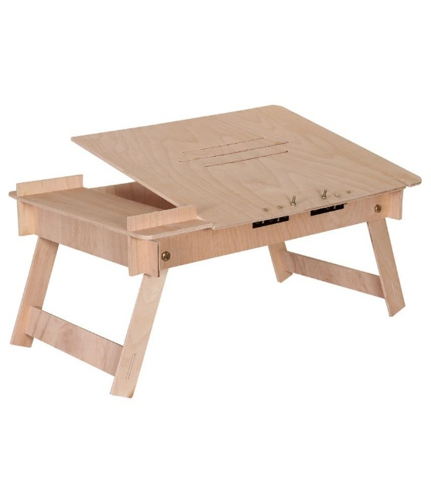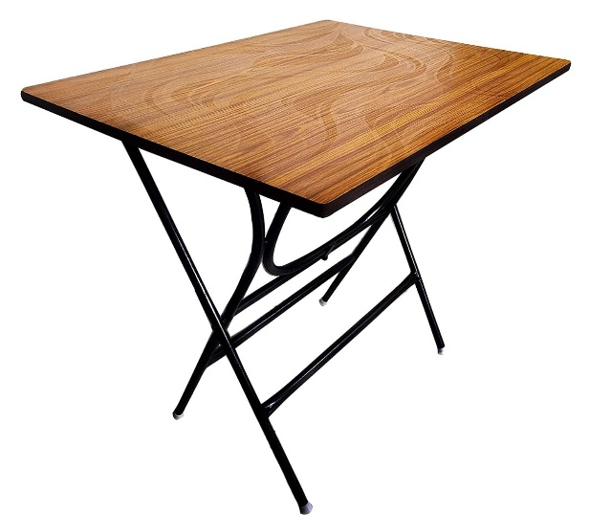The materials used are user-friendly which can be used by the user without any strain.

Wood replaced with iron

**Benefits:-**

* By replacing wood with iron and fibre we are able reduce the cost.
* Also, wood is easily available and eco-friendly material to use.

**2. ADOPT:-**

* Some of the ideas were adopted from different gadgets/products.
* Having the similar concept used in elevation of tractor box and elevation of selfie stick or telescopes, we can able to adjust the height of table based on our use.

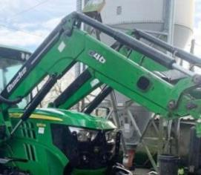

* Just like foldable mobiles having hinge to fold (or) doors having hinge to open/close . Similarly, upon using this idea we can able to fold laptop table at middle or extend it whenever required.

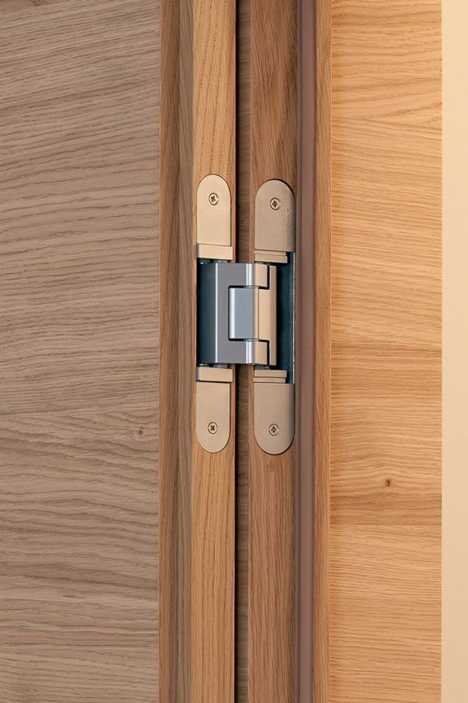

**Benefits:-**

* Thus, upon using these ideas we can able to modify our table so that new features like folding, extending table and can elevate laptop up to our required height.

**3. MAGNIFY/MINIMIZE/MODIFY:-**

* We can modify the existing one’s with introduction of new features helping consumers to use compatibly.
* In future there is a scope to modify our design based on conditions so that it becomes more effective and efficient.

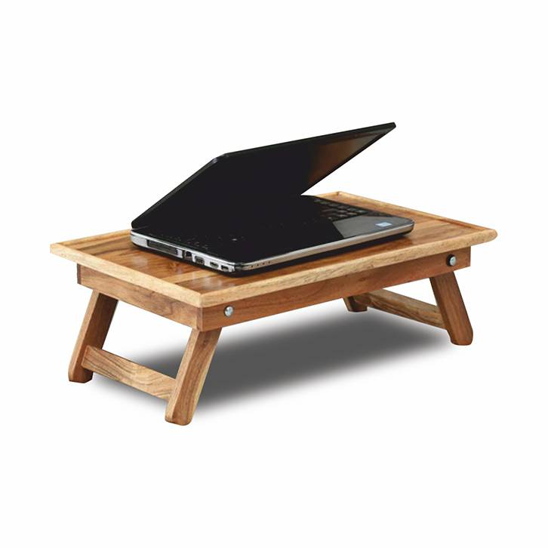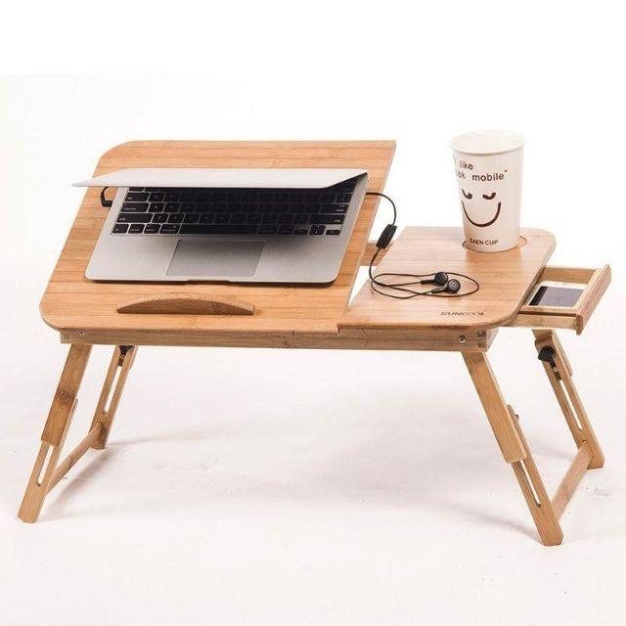

Minimising problems

**Benefits:-**

* Thus, modifying existing one and adding extra features helps to minimize the difficulties faced by user while using laptop table.
* This helps user to use comfortably and satisfy all his needs.

**4.PUT TO OTHER USES:-**

* Other than studying the modified table can be used for various purposes like:-

1. Consuming food.
2. To have discussions for more than one persons.
3. While doing homework.
4. While working with laptop.

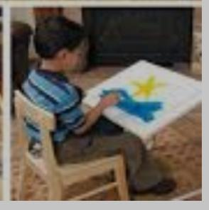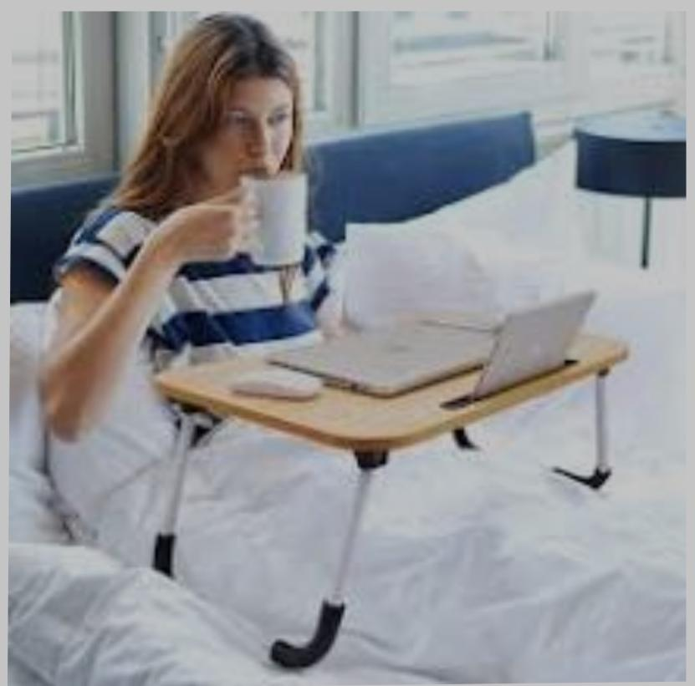

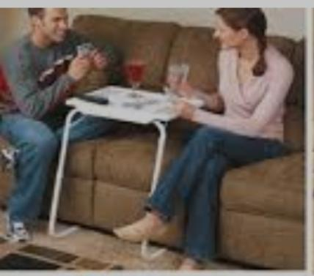

**Benefits:-**

* Thus, this product can replace many single usable products.
* It can be used for variety of purposes.

**5. ELIMINATE:-**

This product eliminates the existing problems and helps to bring effective solution.

**6. REARRANGE:-**

We can rearrange the product after use. After using it can be folded and put at any corner of the room.

Even the elevation for laptop can also be rearranged after use. And can be lifted up when in use.

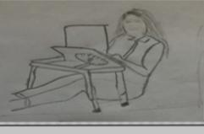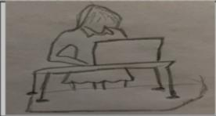

**Benefits:-**

* we can able to arrange it after use and can be adjusted based on our height.
* It can be arranged based on the use and placed at corner after use.

**3.1.2 Concept Sketches:**

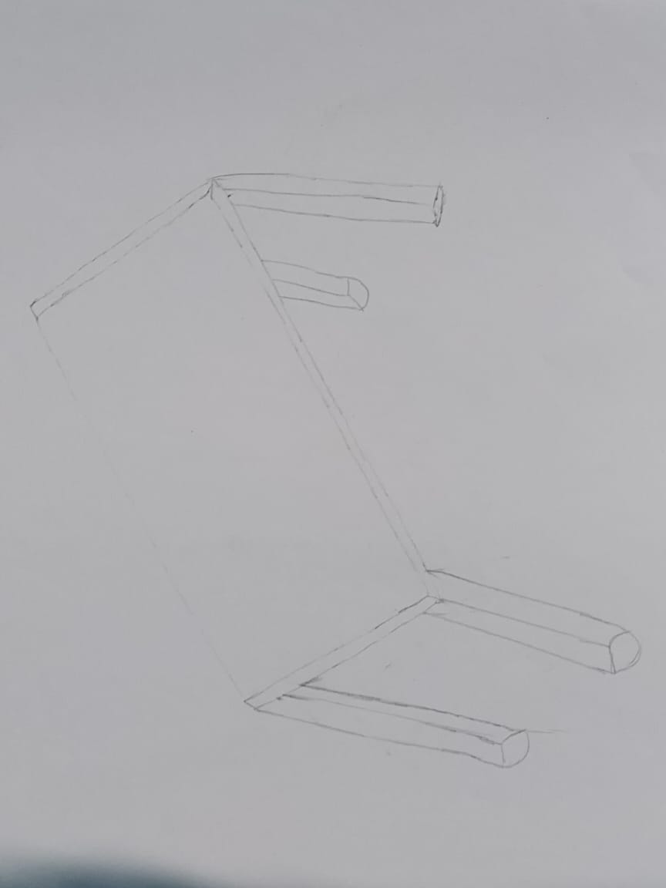

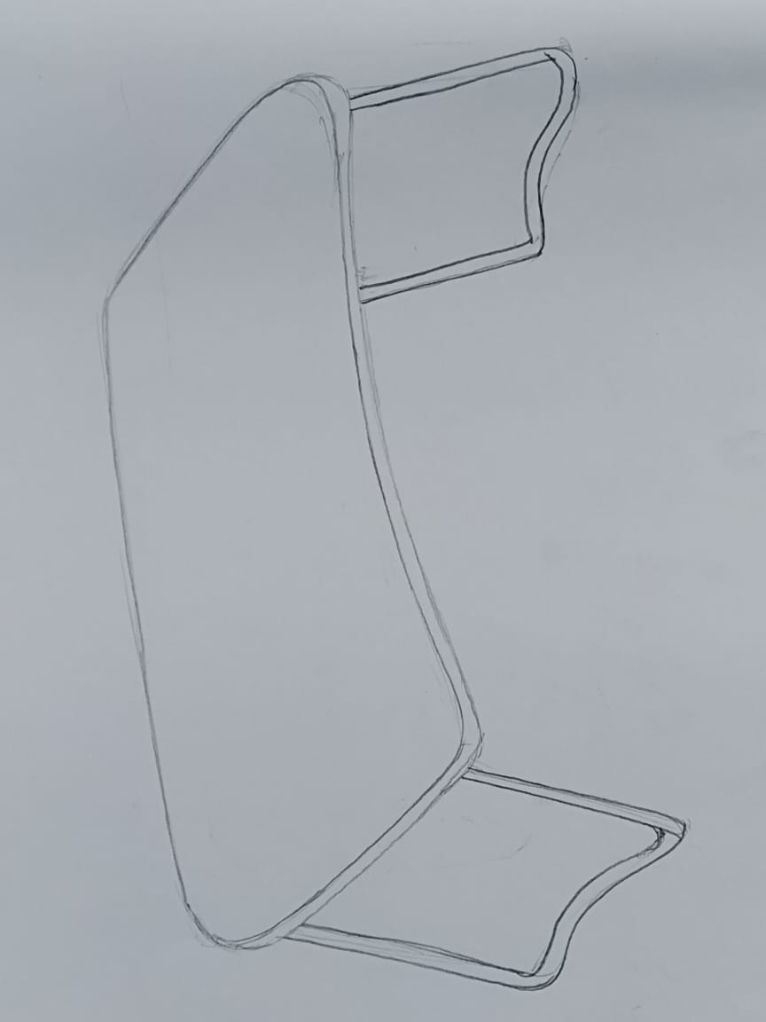

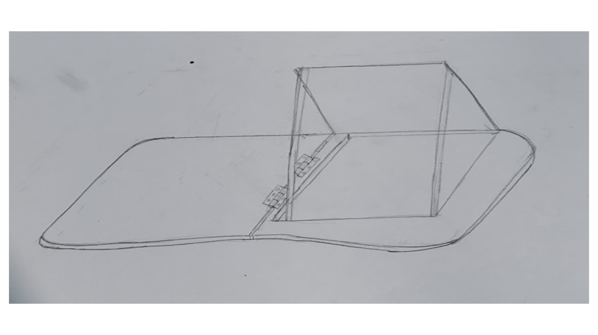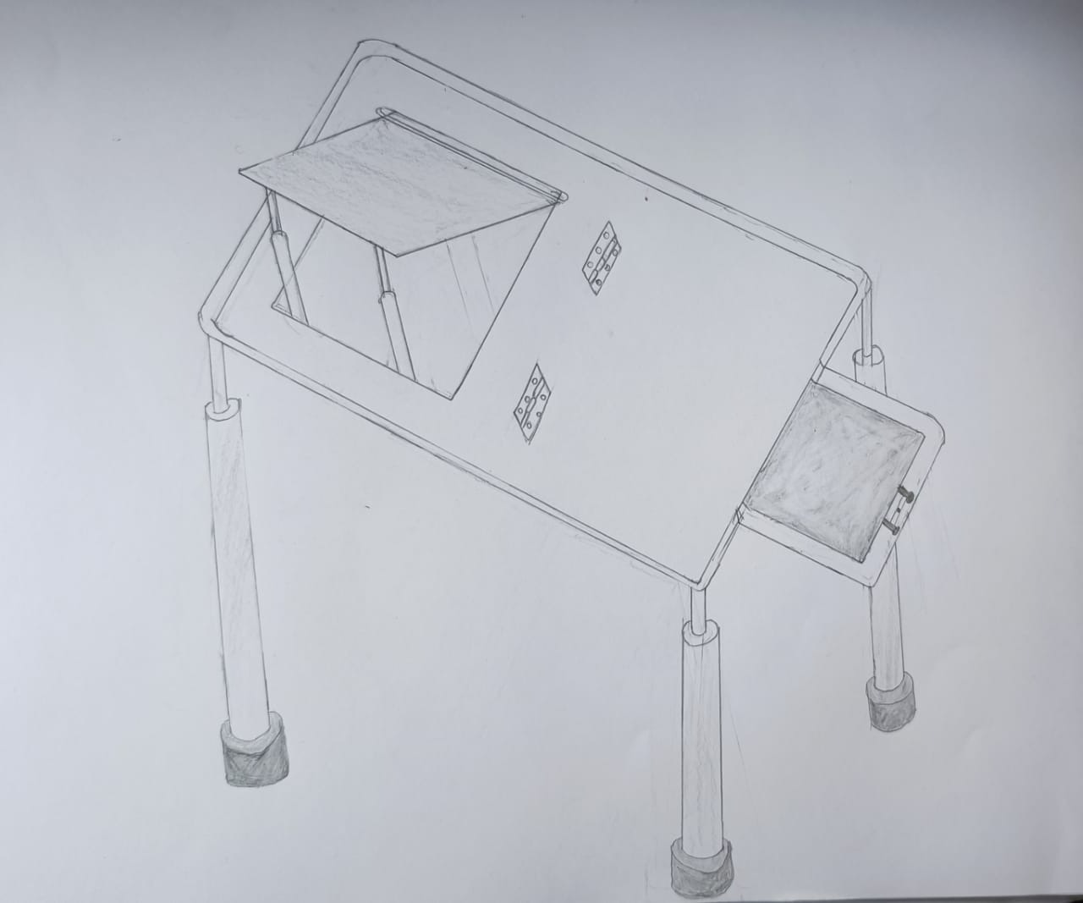

**3.2 Concept Selection**

**3.2.1 Parameters used:**

Feasability: our product is easy to prepare as the materials required are easily available with less cost.

Value: As the product has many new features compared to existing product it will have more demand in market value.

**3.2.2 Concept selected using tool-reasoning:**

We have finalized to design a laptop table as the product has many effective features like:-

* It can be adjusted to our required height.
* Laptop elevator is made so that user can adjust it to his required eye sight.
* It can be folded when ever not in use.
* A fibre material is covered with the elevator so that heat releasing from laptop can be absorbed which improves durability of laptops.
* A desk is provided to store books, mobiles, adaptors etc.

**Chapter 4**

**Prototyping**

**4.1Product Architecture:**

**4.2CAD Model:**

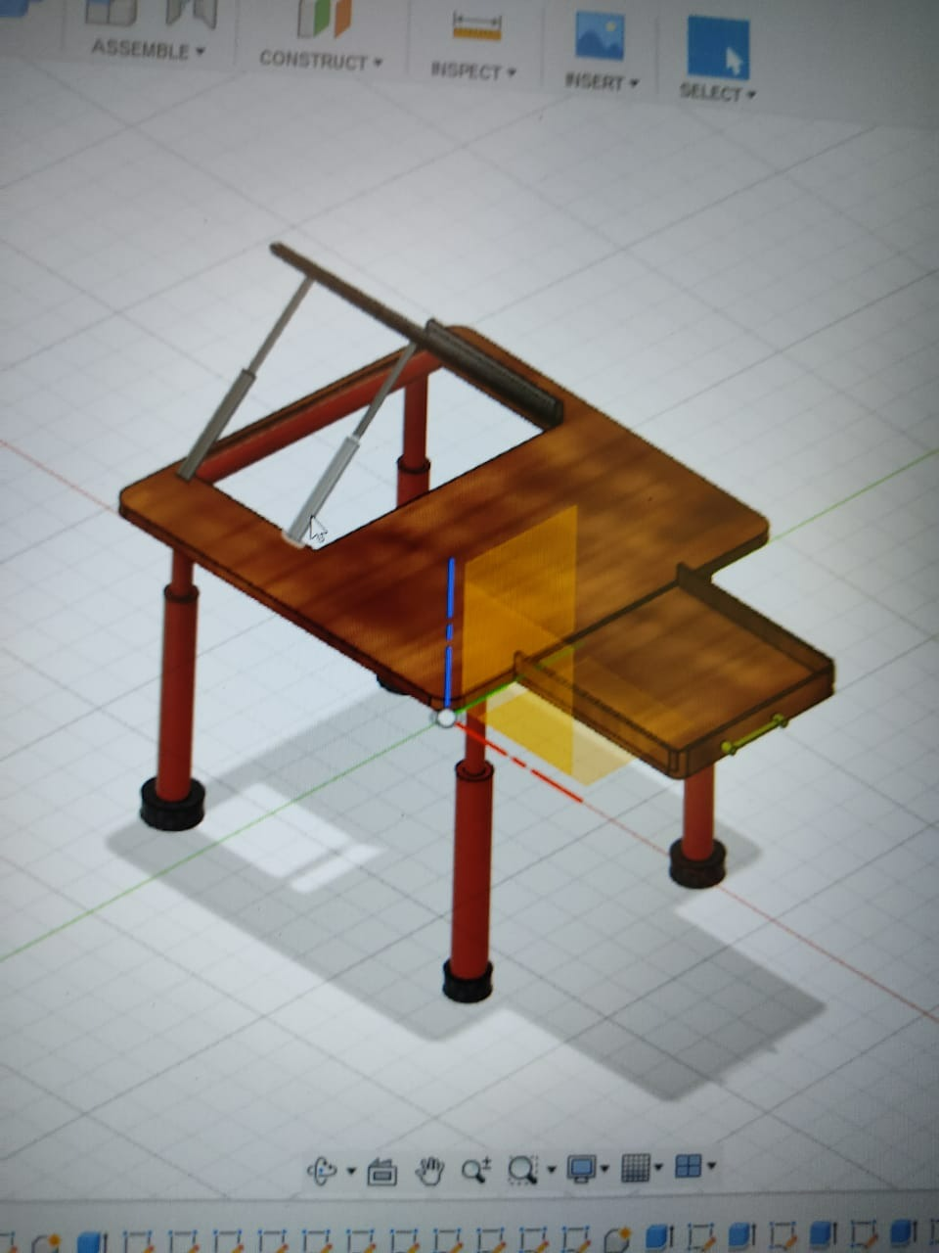

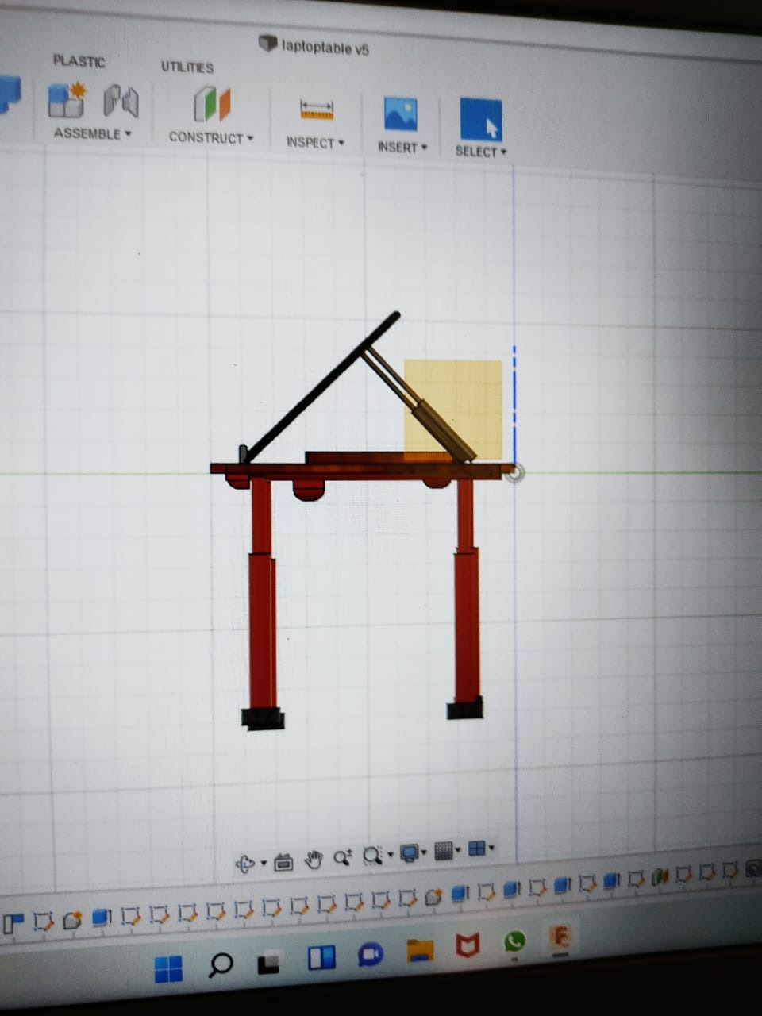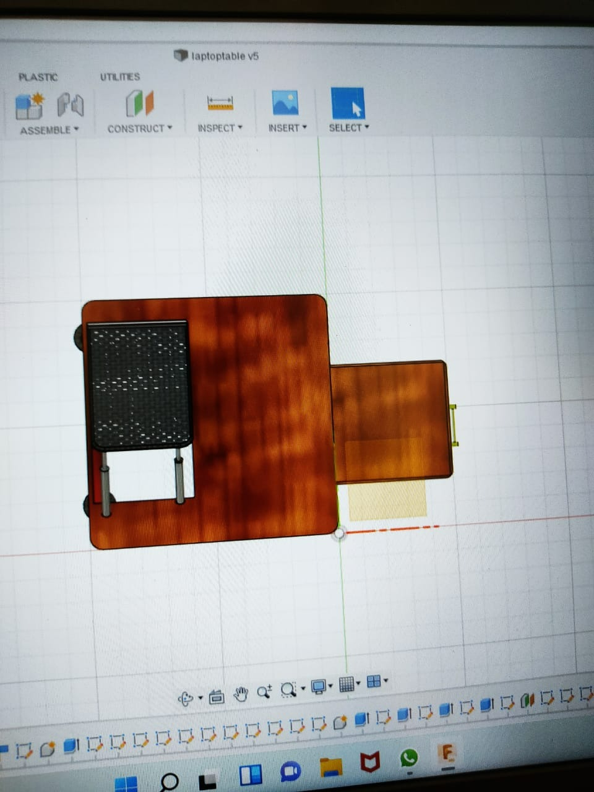

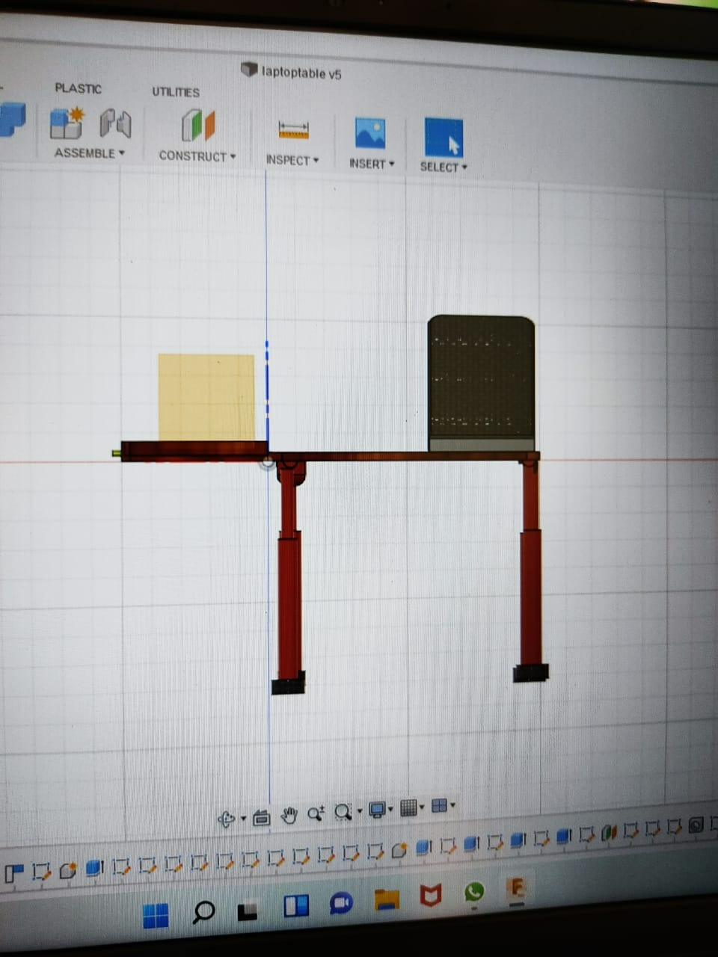

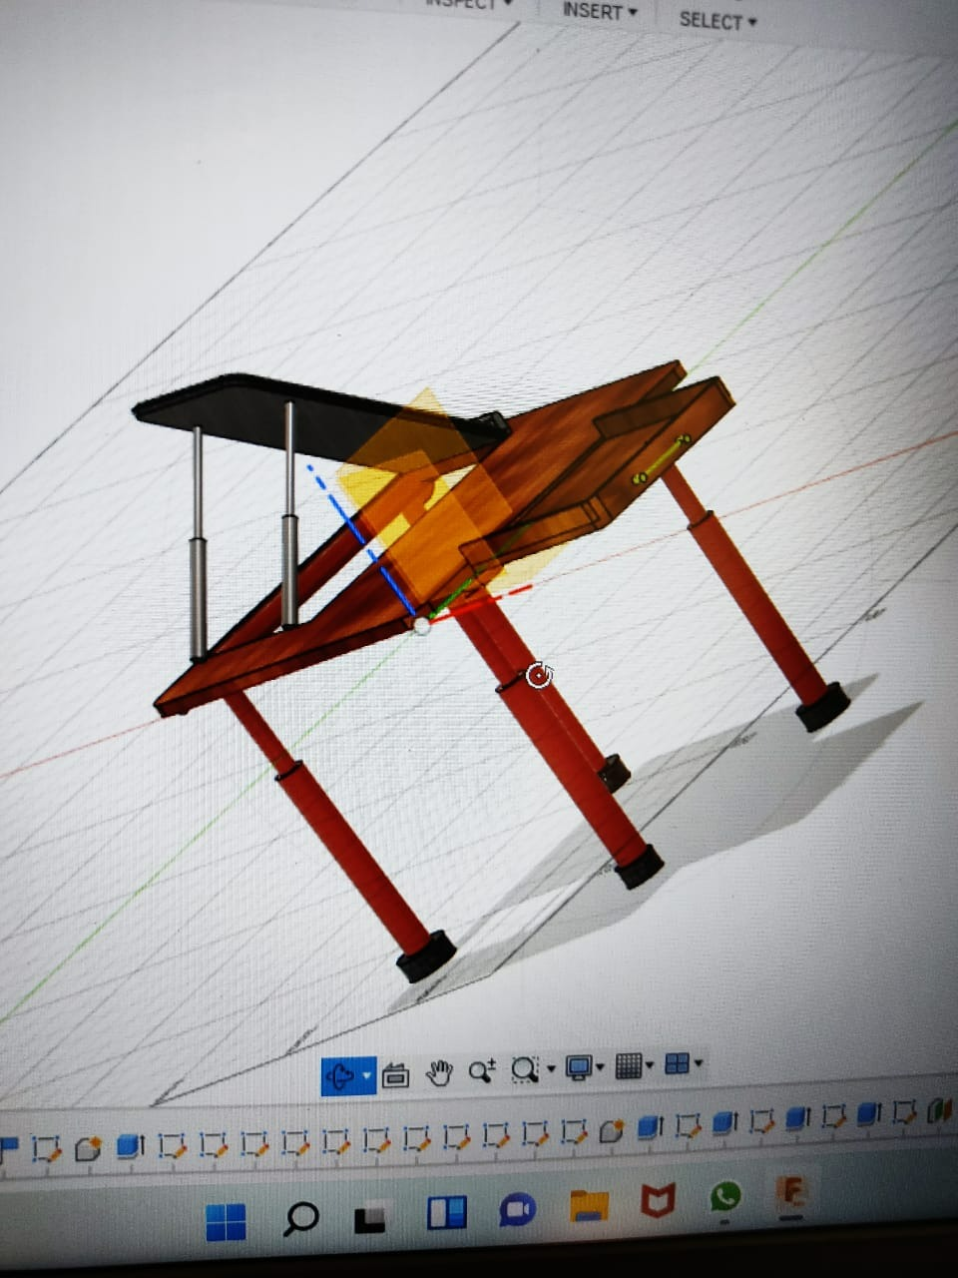

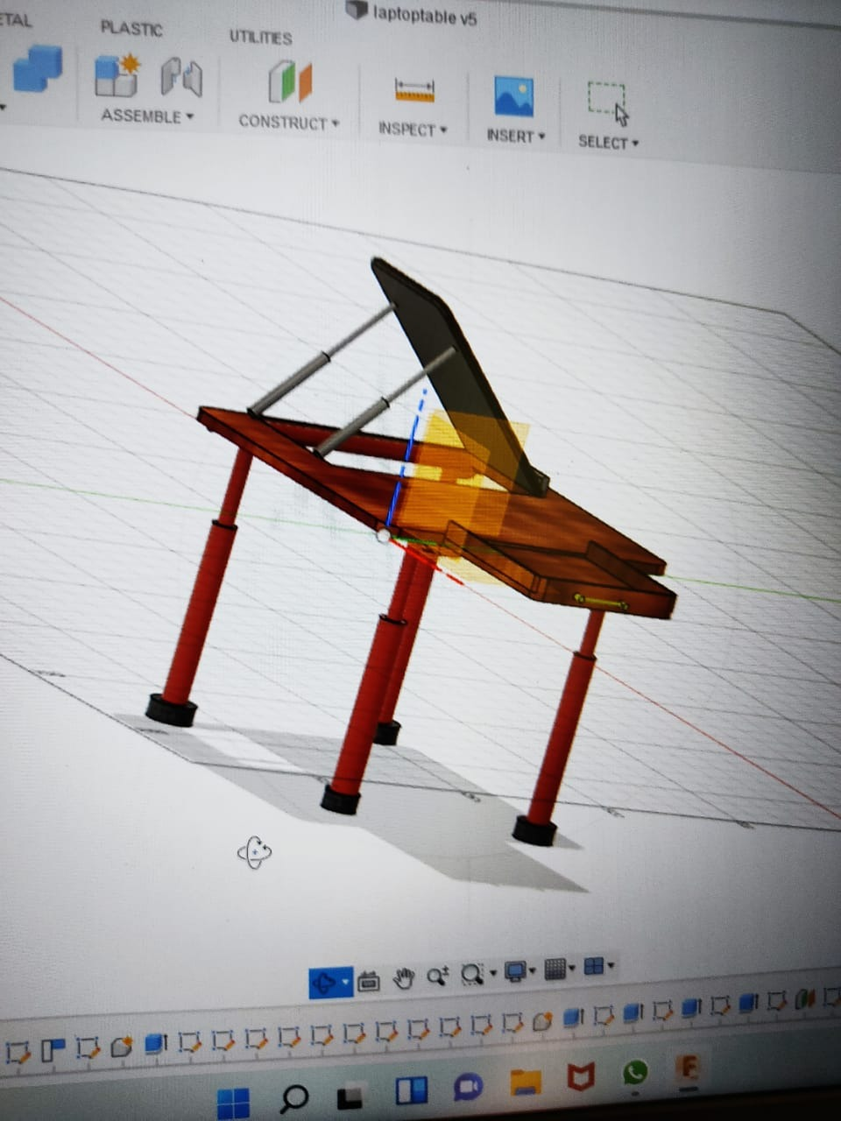

**Chapter 5**

**User Testing**

**5.1 Idea Pitching – Story boarding using value proposition canvas:**

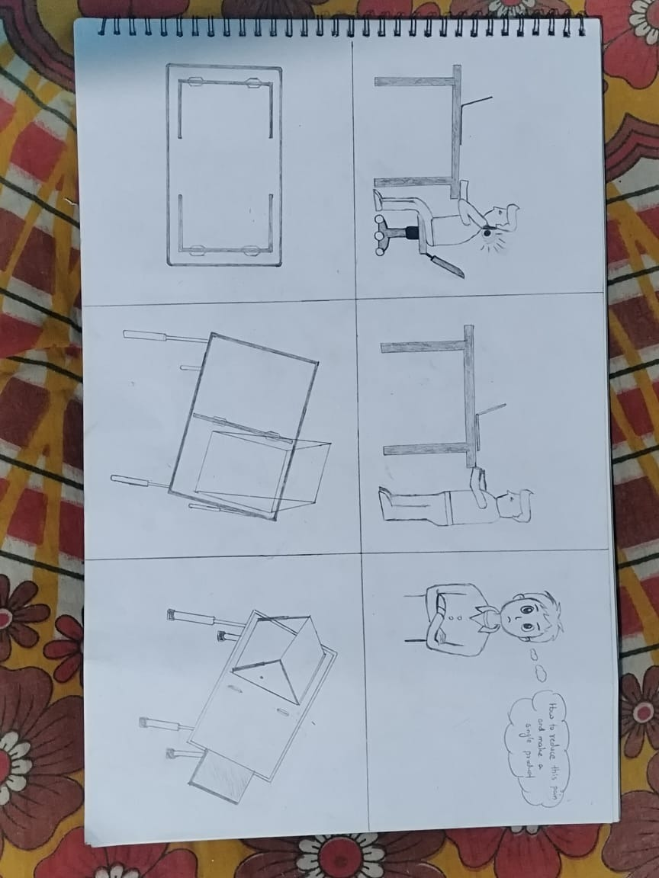

**Chapter 6**

**Conclusion and Future Scope**

From our research we can conclude that our product is very useful for students while studying. It can become a good replacement for the existing laptop table

Coming to future scope, our product can also be modified further. Some of the modifications like adding more laptop elevators, adding cup holders, mobile holders. Thus, we can say that our product has many advantages and can be used for multiple-purposes.